LAB: COMBUSTION Name:
Purpose

Reaction: C₂₅H_{52 (solid) +} 38 O_{2 (gas)} 25CO₂ _{(gas)} + 26H₂O _{(liquid)}
Balance, Include phases
Safety
1) We will have open flames in the laboratory. Make sure that your hair and any loose clothing that you are wearing do not come into contact with the flames.
2) Wear your safety goggles at all times during the session.
3) Make sure that all flames are extinguished properly when you are finished and that matches and other flammable materials are disposed of properly.

Procedure
1) Light the candle and drip a few drops of wax onto the card. Place the candle on the melted wax and hold until frozen. Measure and record the mass of the candle/card to be tested to the nearest
0.01 gram.
2) Add about 100. mL of water to the can. Record exact volume.
3) Before lighting the candle, set up your apparatus as demonstrated by your teacher. When you are sure that everything is set up properly, record the initial temperature of the water in the can just prior to lighting the candle. Estimate the temperature to the nearest 0.1ºC.
4) Light the candle and place under the soda can. Record the highest temperature reached after 10 minutes. Stir carefully with the thermometer. Continue to stir and watch the temperature even after the candle is out. The temperature may rise a little more. Weigh the candle after combustion.

Data table
Initial mass of candle + card | 33.01g
Volume water | 87ml
Initial temp of water in can | 20ºC
Final temp of water in can | 100ºC
Temperature change of water in can | 80ºC
Final mass of candle + card | 31.48g
Mass of wax burned | 1.53g

Calculations
- Mass of water heated. (density of water=1.0 g/ml)
$$Mass=Density×Volume$$
$$=1.0 \left(\frac{g}{ml}\right)×87ml$$
= 87g

- Heat absorbed by the water.
$$H=m x C x ∆T$$
$$H=\left(\frac{87}{1000}\right)Kg x 4200\frac{J}{Kg˚C} x 80˚C$$

=29120.64J
= 29.12KJ

- Heat released by the wax.
Heat Released by Water = Heat released by the wax
Therefore, heat released by the wax;
= 29.12KJ

4. Calculate the moles of wax reacted
$$Moles=\frac{Mass}{Molar Mass}$$
Mass of wax=1.53g
Molar mass of wax (C₂₅H₅₂) = 353
$$Moles=\frac{1.53}{353}$$
=0.004334278 moles

- Heat of combustion for wax in Kj/mole
$Heat of combustion =\frac{Heat released by the wax}{Moles of wax reacted}$$$Heat of combustion =\frac{29.12KJ}{0.004334278 moles}$$
=6718.68KJ/mol

- Write the reaction with the amount of heat in the reaction in the appropriate place (is this endothermic or exothermic?)
C₂₅H_{52 (solid) +} 38 O_{2 (gas)} 25CO₂ _{(gas)} + 26H₂O _{(liquid)} ∆H= 29.12KJ-6718.68KJ = -6689.56KJ
Therefore, the reaction is exothermic since ∆H is negative.
Questions:
1. Using your reaction in #6, calculate the heat released if 15.3 g of wax is burned.
$$Moles=\frac{Mass}{Molar Mass}$$
Mass of wax=15.3g
Molar mass of wax (C₂₅H₅₂) = 353
$$Moles=\frac{15.3}{353}$$
=0.04334278 moles
Heat released= 6718.68KJ* 0.04334278
=291.21KJ

2. Draw the appropriate energy diagram for this reaction.

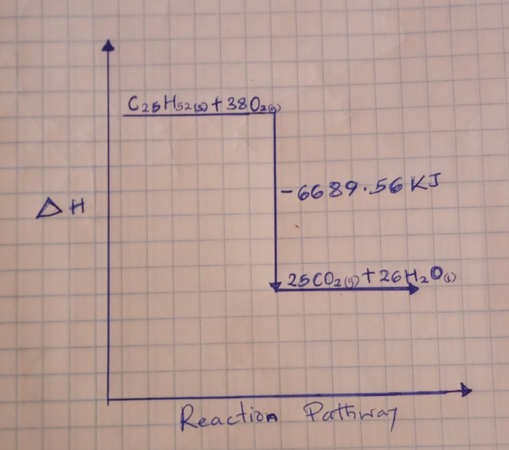

- In this reaction, is the entropy increasing or decreasing? Explain why.
The entropy increases since the reaction is exothermic, releasing the energy into the environment.

